**ORACLE LAB-PRACTICE**

**Dhanush kumar K**

**731621106008**

**KSRIET**

**1.CLIENT MASTER TABLE CREATION**

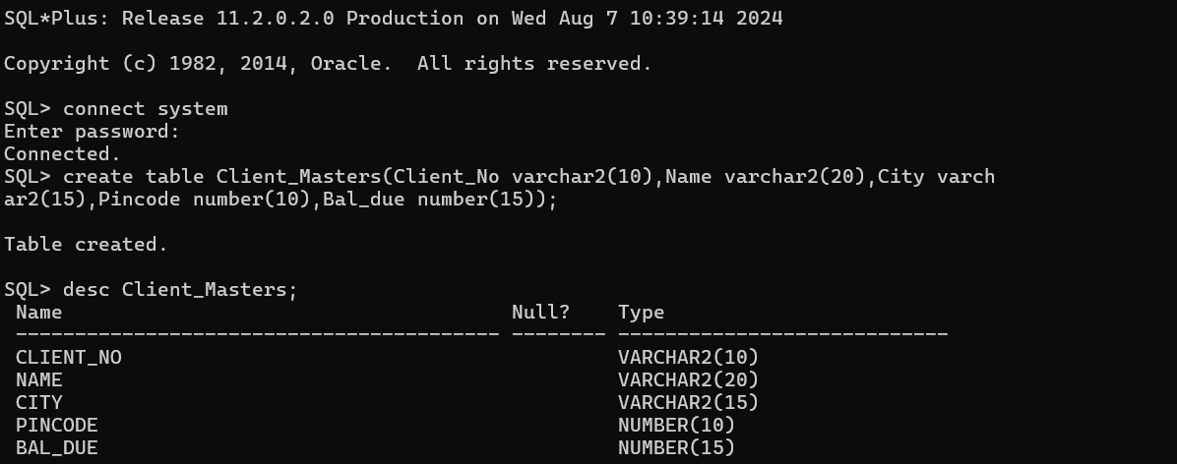

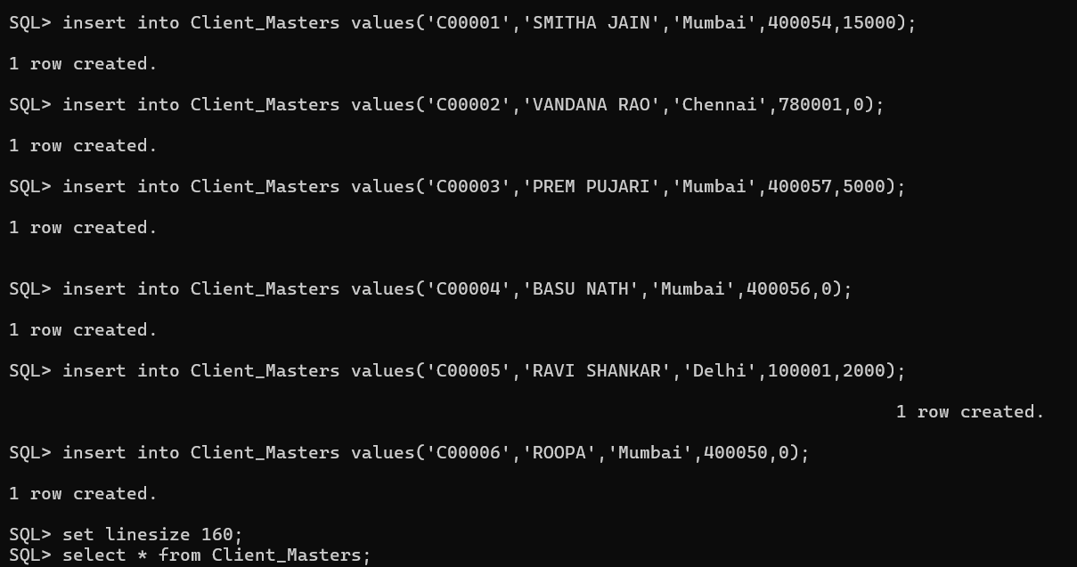

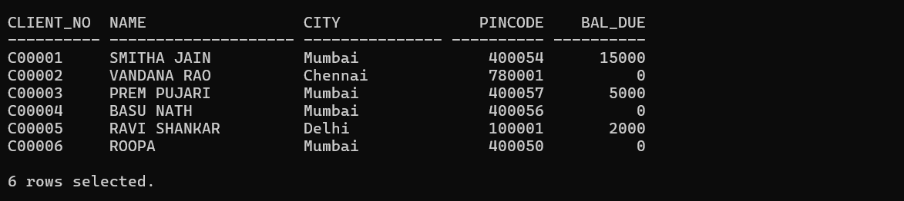

|  |  |
| --- | --- |
|  | **1.List all details from the client_master table for clients whose Bal_due=0.** |
|  | **2.Update table client_master, Change city of Client_no C00004 to Jaipur.** |
|  | **3.Retrieve records of clients residing in Mumbai.** |
|  |  |

**2.SALE_ORDER TABLE CREATION**

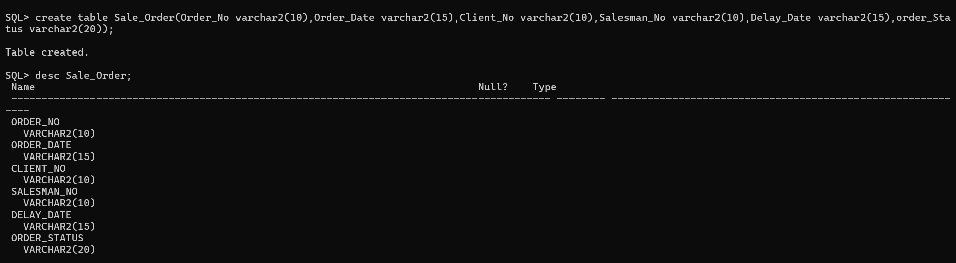

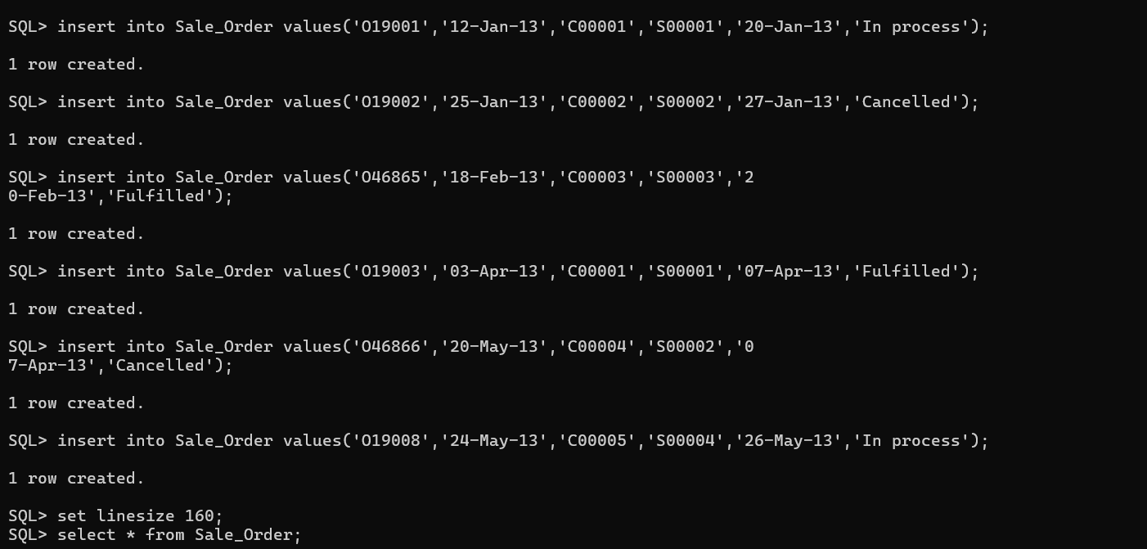

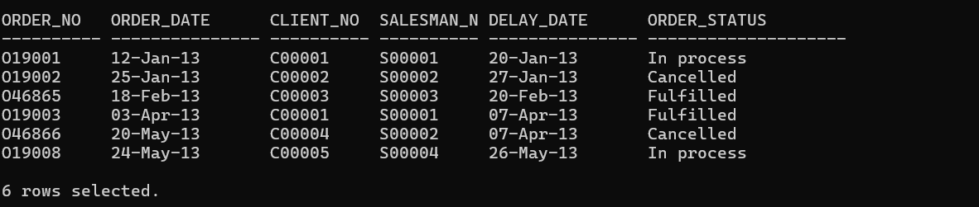

|  |
| --- |
| **4.Find the name and address of customer who has placed Order_no 'O19003' and 'O19002' respectively.** |
| **5.Construct English like sentence from the table client_master ({Customer name} live in the city of {city}).** |